Legs and Shoulders (15 mins)
Marching Glute Bridge
While doing the ab bridge, lift one knee towards chest and hold for two seconds. Do 3 sets of 15 reps on each side.
Inverted shoulder press
On hands and feet, butt in air, do a press downward. Do 3 sets of 15 reps
Alternating switch lunge
3 sets of 10 reps on each side
Skater hops
Alternating skis, use a medicine ball if possible. 3 sets of 20 reps on each side
Rotating T extension
In a push up position rotate to put one hand in air and switch. Do 3 sets of 15 reps on each side

RUNNING:
Short- do 3 min warm up, 10 mins intervals, 2 min cool down
Long- do 6 min warm up, 20 mins intervals, 4 mins cool down

Abs and legs (15 mins)
Leg curl
With feet on a stability ball, do a bridge where feet roll ball to and from body. Do 3 sets of 20 reps
Seated oblique twist
While sitting, curl knees close to chest with feet and back off ground. With medicine ball if possible twist from side to side. Do 2 sets of 20 reps
Lateral lunge
Lung far out to the side and alternate. Do 3 sets of 15 reps on each side
Superman press
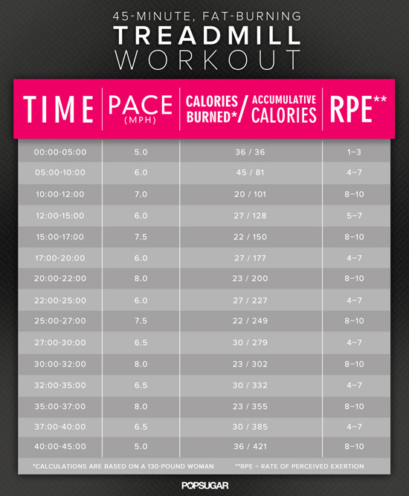
While on stomach and doing a superman, lift legs and arms as high as possible while keeping everything tight, that’s a rep. Do 3 sets of 15 reps

RUNNING:
Short- 1-2 miles
Long-

Arm Yourself (15 mins)
Plank-up
In plank position, get up on hands, then get back down on elbows, do 3 sets of 15 reps
Combo Shoulder Raise
With dumbbells and sides, raise dumbbells in front of chest then move outwards to make body into a “T.” Do 3 sets of 15 reps on each side
Alternating Shoulder Press and Twist
With dumbbells on shoulders, lift up. Do 3 sets of 15 reps on each side
Stability-ball pullover
With shoulders on stability-ball, and feet on floor making a bridge, do the tricep lift behind head and then back in front of face. Keep arms straight. Do 3 sets of 10 reps.
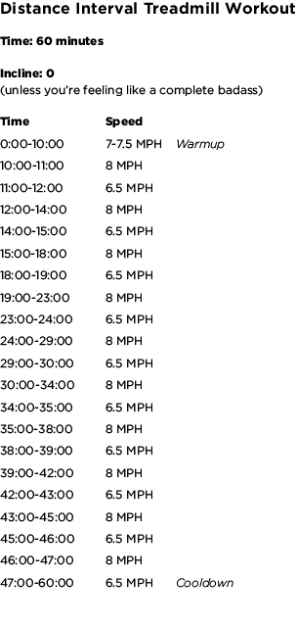
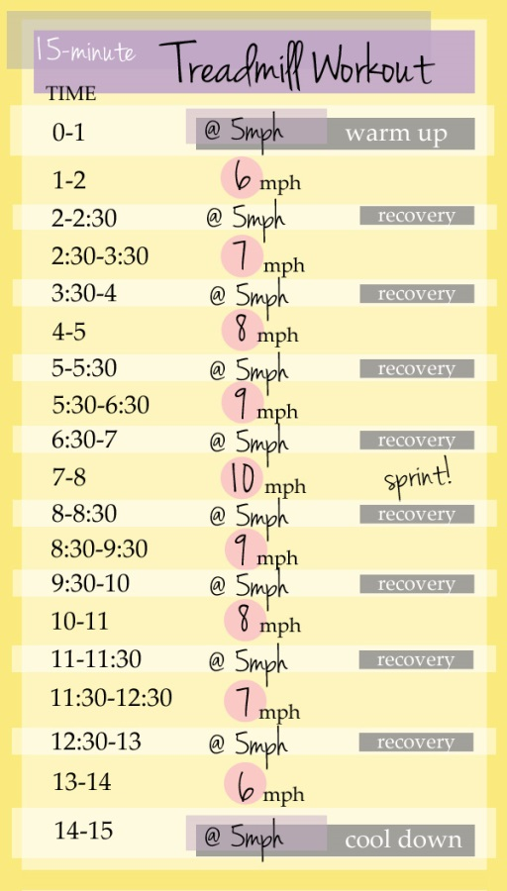
RUNNING:
Short-
Long-
Total Body Blasts (45-60 mins)
Stability-ball rollout
With elbows on ball, and knees on floor, roll arms out and then back in. Do 3 sets of 10 reps
Stability-ball plank
With feet on ball and hands on floor, roll feet towards body. Legs stay straight and body should angle to an upside down “V.” Do 3 sets of 10 reps
Lying Leg Extension
Lying on back, shoulders off the ground start with knees bent towards chest with arms at knees, and move arms and legs as far out as possible. Do 3 sets of 10 reps
Rotating Side Plank
Start in plank position and rotate from side to side for 2 seconds each. Do 3 sets for 30 seconds of rotating.
Full-extension Squat
While squatting down straighten arms to side, then when coming up, go on tippy toes along with arms straight out in front of chest. Do 8 sets of 20 second rounds. Go as fast as possible
Switch lunge
Do as many as possible in 8 sets of 20 seconds
Cardio Run:
0:00-0:30 jog at slow pace
0:31-0:50 run at moderate pace
0:51-1:00 sprint
1:01-5:00 repeat the interval 5 times
5:01-6:59 walk
7:00-12:00 repeat interval 6 times
Dumbbell squat
Dumbbells at hips, do 3 sets of 15 reps
Pushup
Do 3 sets of 15
Bent-over row
Do 3 sets of 15
Goblet Split Squat
With one leg in front of the other, bend down. Hold dumbbell with both hands at chest under chin. Do as many as possible for 30 seconds on same leg then switch legs. Do 3 sets of 30 seconds on each side
Push up position row
In pushup position, with dumbbells, move arms to chest. Do 3 sets of 10 reps on each side
Overhead press
Lift up. Do 3 sets of 20 reps
Run
Warm up for 2 mins
Intervals for 10 mins (one min sprint one min walk)
Cool down for 3 mins
IF TIME DO ELLIPTICAL

Fast arms (15 mins)
Split Squat
Legs staggered and dumbbells by hips. Bend down five times on the same leg then switch. Do 3 sets of 5 reps on each side.
Incline Pushup
With hands on a bench, do pushups. Do 3 sets of 15 reps
Lat Pull-Down
With the cable machine, pull down in front of chest. Do 3 sets of 10 reps
Triceps dip
On a bench, dip downwards. Do 3 sets of 10-15
RUNNING:
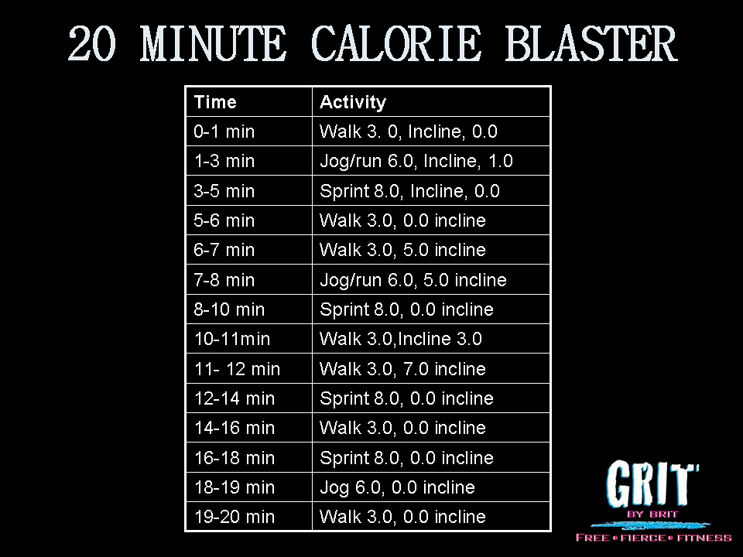
Short-
Long- Run 5 miles
Program A (20 mins)
Global squat
Squat with dumbbell at chest Do 3sets of 10-12 reps
Pushup
Do 2 sets of 15 reps
Elevated hip thrust
Shoulders on bench, raise hips up and hold. Do 3 sets of 10-12 reps
Inverted Row
At cable machine, put bar low. Lay down under bar and pull self to bar. Do 3 sets of 10-12 reps
Plank
Do 3 sets of 60 seconds
RUNNING:
DO 3.11 miles

Program B (25 mins)
Clean-grip deadlift
With a bar on the ground, squat down then bring bar up with hips forward. Do 3 sets of 10-12 reps
Dumbbell push press
Squat down with dumbbells at shoulders, when going up, press weights up. Do 3 sets of 10-12 reps
Reverse sliding lunge
While doing a staggered squat, move one leg backwards to do lunge. Then slide leg back forward. Do 3 sets of 10-12 reps on each side.
Chin ups
At cable machine, have bar low enough to reach. Set weights too heavy to move. Do 3 sets of 10-12 reps.
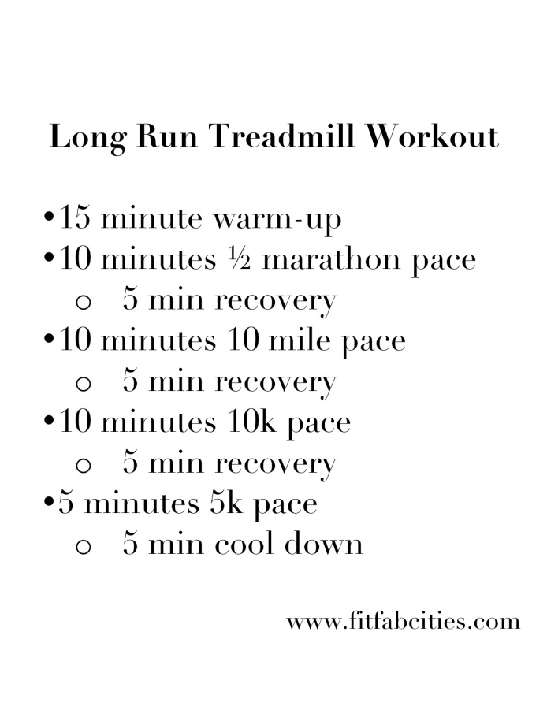
Side Planks
Do 3 sets of 60 seconds on each side
RUNNING:

Legs (20 mins)
Lunge Run
For 30 seconds, while in a deep lunge on one side, pump arms like running. Then switch to other side fast. Do 5 sets on each side of 30 seconds
Burpee
Jump up, Jump back, Push up, Jump up. Do 3 sets of 45 seconds
Skier Swing
Feet on ground bend knees and jump up with whole body. End on toes, swinging arms in air. Keep arms straight. Do 3 sets of 15 reps.
Primal pushup
Pushup position, then only bend knees to chest. In one motion, put weight on hands and bring one leg to hands. Raise hand of forward leg up. Then reverse movement back to pushup position so to do alternating side. Do 3 sets of 15 reps on each side.
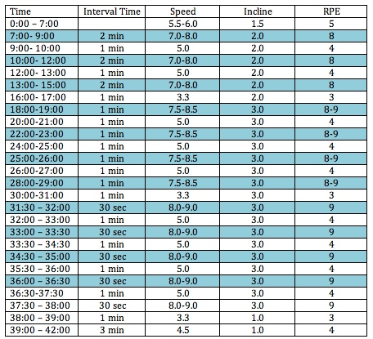
RUNNING:
Short- 2 min warmup, 10 min interval, 3 min cool down
Long-
All Body Sculpt (60 mins)
Hug
On cable machine, with arms straight out with cables in hands; walk out until there is tension in cables. Keep heels together and toes out and thighs together. Bring hands together like hugging then return. Do 3 sets of 15 reps
Twisting curls
Cable machine, start with cables in hands should width apart palms down. Then, twist to make palms up while pulling elbows backwards past back. Do 3 sets of 10 reps.
Shaving
Do bicep curls with cable machine. Do 3 sets of 15 reps
Frogs
With cable machine and the place of movement higher, lay on back. Start with knees bent and feet in grips, move legs straight. Do 3 sets of 15 reps
Hamstring curls
With cable machine, lay face down, and a higher place of movement. Bend legs to butt and then back, go slowly. Do 3 sets of 15 reps
Circles
On back with cable machine, arms by side; get legs off the ground and slowly make a circle away from each other. Do 3 sets of 5 circles going both directions
Pulling straps
With cable machine, have arms out to side to make a “T”. Then pull hands to touch behind back. Do 2 sets of 15 reps
Kneeling butterfly
On knees, with cable machine, put cables in hands at side to make “T”. Twist to have one hand above head and other behind butt. Keep alternating. Do 3 sets of 10 reps on each side
Side bends arm circles
On one side one knee and hand with cable on floor, other side’s leg is extended out straight on floor and hand has cable. Arms make a “T”. Then pull arm in air back towards hips then let cable slack. Do 3 sets of 10 on each side
RUNNING:
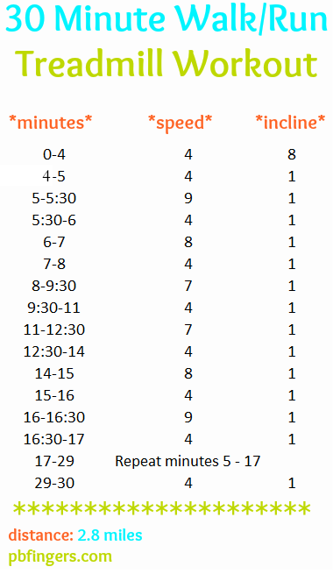
Band Workout (20 mins)
Glute bridge
With band around thighs right above knees, lay on shoulders. Lift back and hips off ground with feet together, spread knees apart, hold for two seconds and then bring back. Do 3 sets of 12 reps
Lateral Shuffle
With band at ankles, shuffle from side to side. Do 3 sets of 10 steps on each side.
Squat
With band on thighs do squats. Do 3 sets of 15 reps.
Knee raise
With band on feet, do high knees slowly. Do 3 sets of 12 reps on each side.
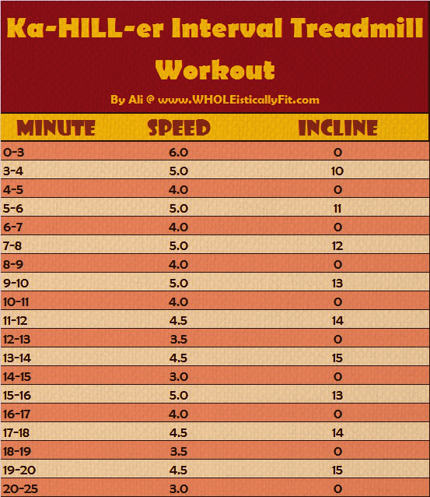
RUNNING:
Short-
Long- Run 6 miles
Abs and Shoulders (60 mins)
Barbell hip thrust
Shoulders on bench and barbell on hips, dip down. Do 3 sets of 15 reps
One- arm bent-over row
Do 3 sets of 20 reps on each side
Goblet low-box squat
Squat with a dumbbell in both hands, under chin, and against chest; Squat until seated on a bench, then using legs, stand back up. Do 3 sets of 8-10 reps
Incline bench press
Do 3 sets 20 reps
Plank
3 sets of 90 seconds
Deadlift
3 sets of 20 reps
One arm should press
Do 3 sets of 20 reps on each arm
Side step ups
Step up on bench with one leg and bring the other leg up, but not setting it on the bench. Set leg back down but keep other leg on bench. Use weights in hands. Do 3 sets of 20 reps on each side
Chest Supported Row
While lying down on an inclined bench, row a dumbbell up to chest. Do 3 sets of 20 on each side

Side plank with clamshell
Do side plank then raise outer knee to make a triangle, keep feet together. Alternate after each set Do 3 sets of 20 on each side
RUNNING:
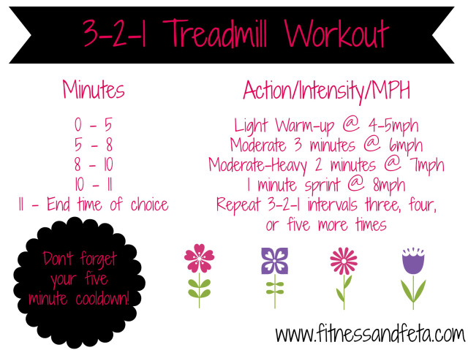

Just Arms (15 mins)
Narrow stance goblet squat
Squat that is narrow and has one dumbbell help by both hands under chin by chest. Do 3 sets of 15 reps
Single-arm bet over row
While on bench row up. Do 3 sets of 25 reps
Sing arm chest press
On back push one arm up. Do 3 sets of 25 reps
Dumbbell swing
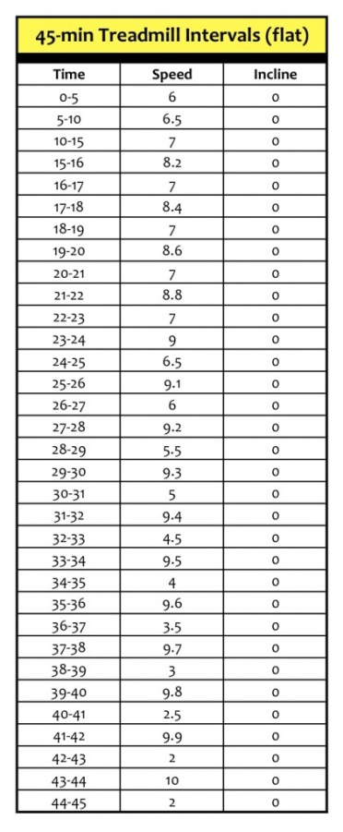
Like woodchuck, swung between legs and stops at chest. Do 3 sets of 25 reps
RUNNING:
Short- Run 1-2 miles
Long-
Flat Abs (45 mins)
Rope climb
While sitting down, have everything but butt off the floor. Have one arm and the other leg in air and then switch by twisting. Do 3 sets of 20 reps on each side
Track-start deadlift
Start in the lunge position with arms by feet with a dumbbell. Then straighten out both legs while keep back parallel with ground, and arms tight towards ground. Do 3 sets of 25 reps
Plank to pop-up squat
Start in plank position then pop up into a squat. Do 4 sets of 60 seconds
Reverse lunge with front raise
Alternating lunging with arm raises with weights. Do 3 sets of 10 on each side
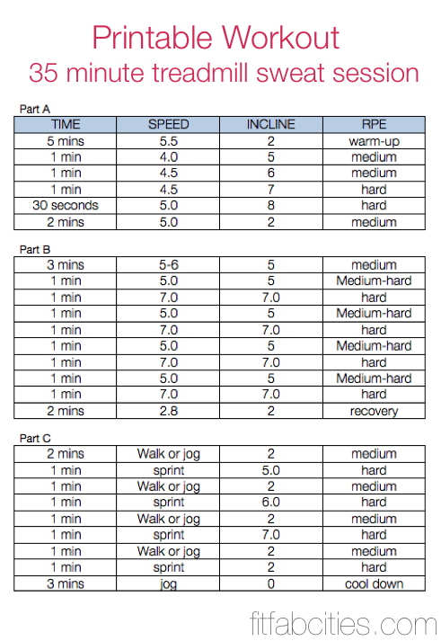
Pushups
Do 4 set 15 reps
Change-up split hop
Wide feet, jump lunge then go back to hop position, then switch leg. Do 4 sets of 10 on each side
Bicycle with a medicine ball
Ball in between knees, then use one elbow to steady ball against knee then twist to try and change arm and knee do 3 sets of 10 reps on each side
RUNNING:

